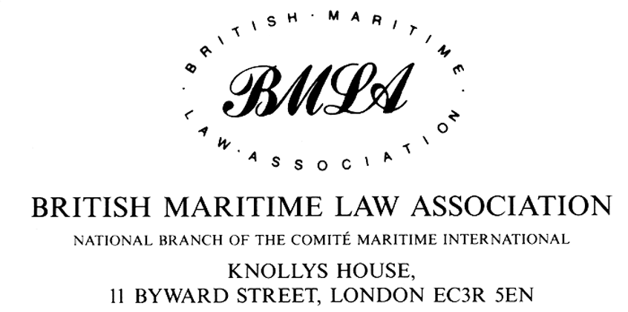
Please reply to:
PATRICK GRIGGS Telephone: 0207 551 8223
SECRETARY or 020 7623 2011
AND TREASURER Internet: http://www.bmla.org.uk Fax: 020 7623 3225
Email:
patrick.griggs@ince.co.uk

3 June 2003

Mr Fotis Karamitsos
Maritime Safety Unit
DG for Energy and Transport
European Commission
28 Rue Demot
Office 2/84
1000 Brussels
Belgium

Dear Sir

Proposal for a Directive of the European Parliament and of the Council on Ship-source Pollution and on the introduction of sanctions, including criminal sanctions, for pollution offences

I write in my capacity as Secretary of the British Maritime Law Association. Members of the Association include The Association of Average Adjusters, the British Insurance Brokers Association, the British Ports Association, the Chamber of Shipping, the Institute of London Underwriters, Lloyd's Underwriters Association, Protection and Indemnity Associations, University Law Departments, Loss Adjusters and Solicitors and Barristers specialising in maritime law. The British Maritime Law Association is affiliated to the Comite Maritime International (CMI).

The Executive Committee of the BMLA has considered the draft Directive and I am instructed to make the following comments.

The principal concern of the BMLA is to ensure that nothing is done which may conflict with or otherwise effect the existing international liability and compensation regime for pollution of the marine environment embodied in the Civil Liability and Fund Conventions of 1992 (plus the substantial increases in the CLC and Fund introduced by resolution of the IMO Legal Committee at its 82nd Session in October 2000) and the Supplementary Fund Convention. These instruments have taken many years to develop and remain under constant review to ensure that the limits of liability and other aspects do not fall out of date. Quite apart from the recently adopted Supplementary Fund it has been noted that the IOPC Fund, through an Inter-Sessional Working Group, is currently reviewing all aspects of the liability and compensation regime established by the various instruments referred to above. Not only have these instruments come into force (currently with the exception of the Supplementary Fund Protocol) but they have been almost universally adopted by the maritime nations.

These instruments have proved to be generally effective in practice ensuring that claimants, be they private or public, receive adequate and prompt compensation following an oil pollution incident. It is recognised that in one or two recent incidents the total amount of claims submitted (but so far not all assessed) exceed the maximum compensation available under these instruments resulting in the need to pro-rate substantiated claims. It is primarily for this reason that the Supplementary Fund Protocol has been recently adopted and the IOPC Fund Working Group is studying other ways in which the compensation package, as a whole, may be improved.

In the view of this Association the international oil pollution compensation and liability regime has demonstrated its flexibility not only in the handling of compensation claims but also in its willingness to address problems which arise in the interpretation and application of the Conventions. It is the view of this Association that pollution of the marine environment should continue to be regulated within the existing framework.

The Association considers that the proposed Directive on Ship source pollution should be viewed against this background.

The essence of the proposed Directive is to criminalise ship source pollution where the discharge is "committed intentionally or by gross negligence". Whilst a discharge of oil intentionally caused may have the necessary criminal attribute of mens rea there can be no justification for imposing criminal sanctions where the pollution results from negligence, whether gross or otherwise. Negligence is generally a civil liability concept and should play no part in the criminal law.

It is worth noting that the whole oil pollution liability and compensation regime is carefully structured so that there is strict liability for pollution (with very limited defences) and compensation flows automatically and is paid promptly. Any new Directive which re-introduces arguments about causation and negligence would run counter to the strict liability basis of the existing civil liability regime.

As the Explanatory Memorandum recognises, deliberate discharges of certain waste and cargo are already illegal in most countries under Marpol 73/78. It would be infinitely preferable for the existing international agreements relating to deliberate discharges to be enforced (even on a regional basis) rather than seeking to create new offences which would apply on a regional basis only. In view of this Association, the Commission would contribute more to its desire for pollution free seas if it concentrated its efforts on encouraging EU states to apply current international agreements.

The Explanatory Memorandum also suggests that the current international civil liability regime is in no sense dissuasive. The BMLA disputes that assertion. However well insured, every shipowner involved in a pollution incident knows that his uninsured losses and his loss of reputation will have a serious impact on his business. The imposition of criminal sanctions would not add to the deterrent effect and, since imprisonment seems to be the contemplated sanction for the offence of pollution, it would simply encourage the creation of more elaborate and opaque corporate structures so that no individual could be identified.

The Explanatory Memorandum draws attention to the fact that under the existing civil liability regime liability is channelled towards the registered owner of the ship and it is the registered owner who is obliged to maintain insurance or other financial security. This so-called “channelling” was designed to simplify the handling of claims both from the point of view of the owner and of the claimant. It is far preferable that the claimant should have one clearly identifiable target who is known to be adequately insured. The suggestion in the Explanatory Memorandum that the Claimant should have the option of seeking compensation from the Charterer, Manager and Operator of the ship is counter-productive and is strongly opposed for these reasons.

The Explanatory Memorandum also suggests that the rights of the shipowner (and his insurers) to limit their liability to the levels stated in the CLC should be lost if the pollution damage resulted from gross negligence. The Commission should remember that before the oil pollution compensation conventions were introduced the shipowner could limit under the general law of limitation provided that he could establish that he had not been at fault or privy to the cause of the accident. Subsequent to the 1969 CLC the general law of limitation was changed by the 1976 LLMC. Under that Convention, in exchange for a substantial increase in limits, the shipowner would only forfeit his right to limit if the loss resulted from the personal act or omission of the shipowner “committed with the intent to cause such loss, or recklessly and with knowledge that such loss would probably result”. The 1969 CLC reflected the general law on limitation of liability and provided that the owner could not avail himself of the CLC limits if the incident occurred as a result of his actual fault or privity. With the change in the general limitation law introduced by the 1976 LLMC, it was thought appropriate to up-date the limitation provisions in the CLC Convention and by Article 4 of the 1992 Protocol to the Civil Liability Convention the right to limit is now only lost if the damage resulted from the personal act or omission of the owner “committed with the intent to cause such damage, or recklessly and with knowledge that such damage would probably result”.

It follows from this that the limitation provisions in the Civil Liability Convention now match the underlying law of limitation (as contained in the 1976 LLMC) insofar as the loss of the right to limit is concerned.

Any change in the test to determine the right to limit in respect of oil pollution claims would thus run counter to the general law of limitation as contained in the LLMC 1976 and as endorsed by Protocol of 1996. The Association would strongly oppose any changes in the underlying limitation provisions of the CLC and Fund Conventions.

Finally, the Association urges the Commission to continue to co-operate with IMO and other international bodies by enforce existing Conventions and Regulations and it urges the Commission to resist the temptation to introduce regulations on a regional basis which run counter to exhaustively negotiated and well respected existing agreements.

Yours faithfully

P. Griggs
Secretary/Treasurer

